Microcontroller & Embedded Systems Lab
Project Report 0`



Semester | 5th
Submitted By | Fatima Nazir
Class | BE-MTS 5B
Roll No. | 201901
Submission Date | 12/10/2023
Submitted To | Ma`am Iraj Kainat
Checked By | Sir Umer Farooq

PCB DESIGN OF ARDUINO UNO
OBJECTIVE:
- To design a schematic using proteus and then make a single layer PCB in same software
- Test the board with heart beat test at pin 13 in C language.
- To understand and read the Basic configuration required to power up ATmega 328P.
INTRODUCTION OF ARDUINO UNO:
Arduino Uno is based on an AVR microcontroller called Atmega328 Arduino is an opensource platform used for building electronics projects. Arduino consists of both a physical programmable circuit board (often referred to as a microcontroller) and a piece of software, or IDE (Integrated Development Environment) that runs on your computer, used to write and upload computer code to the physical board. The Arduino platform has become quite popular with people just starting out with electronics, and for good reason. Unlike most previous programmable circuit boards, the Arduino does not need a separate piece of hardware (called a programmer) in order to load new code onto the board -- you can simply use a USB cable. Additionally, the Arduino IDE uses a simplified version of C++, making it easier to learn to program. Finally, Arduino provides a standard form factor that breaks out the functions of the micro-controller into a more accessible package.
KEY PROJECT ROLES:
We will go through following steps.
- Design
- Implementation
- Testing
COMPONENTS:
- 1 x Arduino-Compatible single layer PCB on Fiber PCB sheet
- 1 x ATMega328P IC • 1 x 5mm Green LED
- 1 x 5mm Red LED
- 2 x 330Ohm Resistor
- 1 x 10kOhm Resistor
- 2 x 22pF Ceramic Capacitors
- 5 x 0.1uF Ceramic Capacitors
- 2 x 10uF Electrolytic Capacitors
- 1 x LM7805 5V Regulator
- 1 x Diode 1N4001
- 1 x Push Button Reset Switch
- 2 x 6-Pin Female Headers • 2 x 8-Pin Female Headers
- 1 x DC Barrel Jack,USB jack like on Aurdino,
ATMEGA 328p IC:
Atmega328p programming controller is an 8-bit microcontroller based on AVR RISC architecture. Atmega-328p ic chip is the most popular of all AVR controllers as it is used in ARDUINO boards.
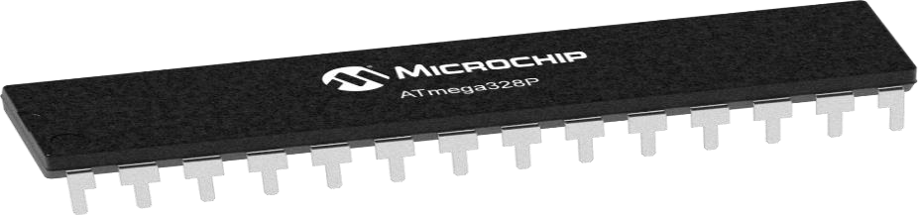
FEATURES:
Parameter |  | Value
CPU type | 8-bit AVR
Maximum CPU speed | 20 MHz
Performance | 20 MIPS at 20 MHz
Flash memory | 32 KB
SRAM | 2 KB
EEPROM | 1 KB
Package pin count | 28 or 32
Capacitive touch sensing channels | 16
Maximum I/O pins | 23
External interrupts | 2
USB interface | No
LM7805:
The LM7805 is a voltage regulator that outputs +5 volts. Like most other regulators in the market, it is a three-pin IC; input pin for accepting incoming DC voltage, ground pin for establishing ground for the regulator, and output pin that supplies the positive 5 volts.
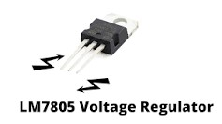
PROTEUS SIMULATION:

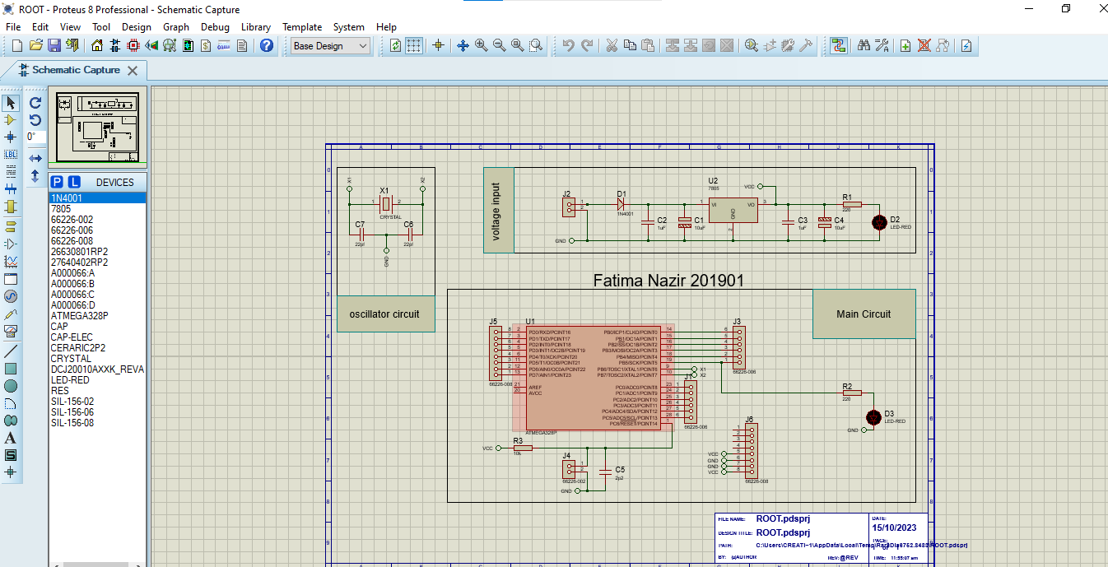

PCB LAYOUT:
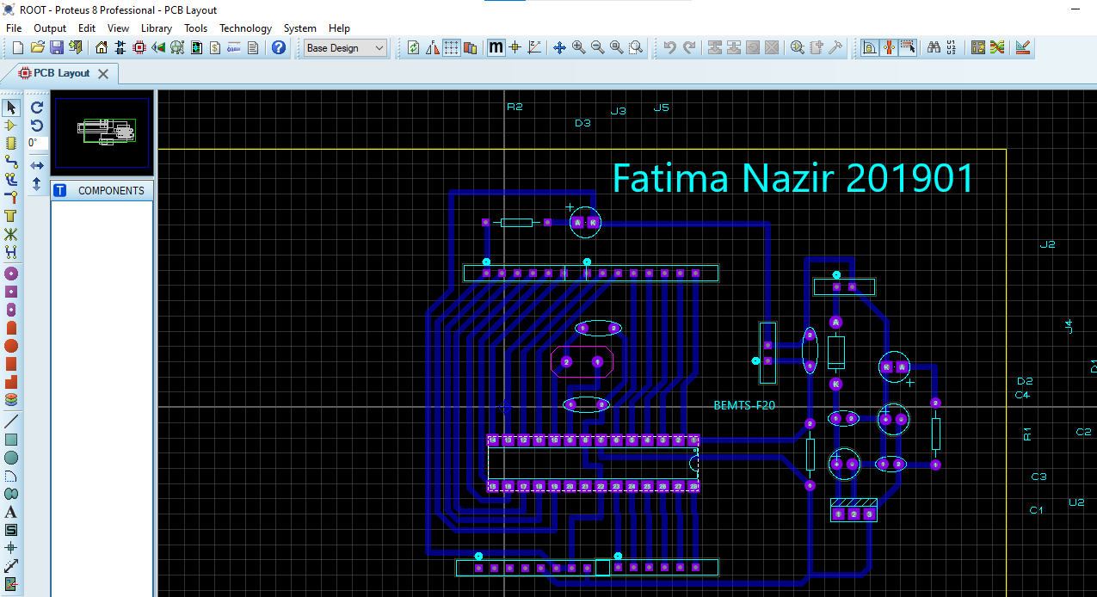

3D VISUALIZATION:

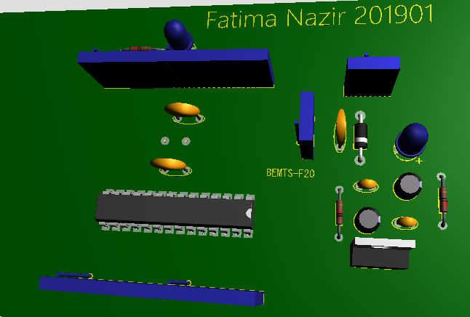
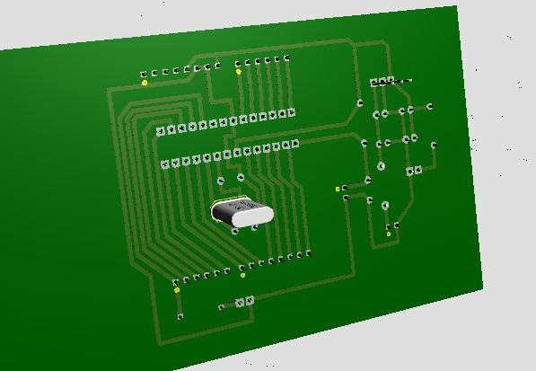

HARDWARE IMPLEMENTATION:

- Project Video:

PROJECT ARDIUNO _{UNO.mp4}
- Youtube Link: https://youtu.be/N6gAIP4U7Sw CODE:
void setup() {
pinMode(13, OUTPUT);
} void loop() { digitalWrite(13, HIGH); // turn the LED on (HIGH is the voltage level)
delay(1000); // wait for a second
digitalWrite(13, LOW); // turn the LED off by making the voltage LOW
delay(1000); // wait for a second
}
CONCLUSION:
In this project, we have learnt:
- How to design a PCB of Microcontroller (Arduino)?
- How to integrate different components with the PCB board?
- How to burn code into the IC (ATMEGA 328p) using Arduino UNO?

